(Approx. 1103 words)

Social Distancing - THANK THE INTERNET
By Phil Sorrentino, Contributing Writer
May 2020 issue, the STUG MONITOR
www.thestug.org
philsorr (at) yahoo.com

The Internet can’t help you wash your hands or sanitize your environment, but it certainly can allow you to remove yourself from groups of people while allowing you to stay in touch, for work and socialization reasons. It helps you adhere to the policy of social distancing or “keeping at least six feet between you and other people.” None of this would have been possible as little as 20 or 25 years ago, let alone the last great Spanish Flu pandemic of 1918. The internet, as we know it, is only around 20 years old or so, depending on how you want to decide when it started. The seeds of the Internet were started way back in the 1960s when the Department of Defense experimented with communications between computers, which eventually developed into a network called Arpanet. Email came along in the 1970s and even rudimentary social networking was attempted in the 1980s with Usenet. Also, TCP/IP, the backbone communications protocols were incorporated into Arpanet in the 1980s. The World Wide Web, the http protocol, and web pages only began to appear in the 1990s along with web browsers (remember Mosaic?) to allow you to access those web pages. And finally, around 2000 we start to see internet giants like AOL, Yahoo, Google, MySpace, Facebook, Twitter, YouTube, eBay, and Amazon. And it’s the giant servers at the other end of the internet that provide all the capabilities that we now take for granted. So, the really useful internet is about 20 years old, but it is constantly changing and molding itself to the needs of the users.

Most of those useful servers are hundreds and even thousands of miles away from us, the users. It is the resources of all those servers, connected to us by the internet that allows us to keep a social distance from other users. It is the internet that is the connective mesh that lets all of us “clients” use the resources of the “servers” no matter how far away they are from us. And with the advent of cell communications, wi-fi, smartphones, and tablets (a.k.a. mobile devices), we can access these servers even when we are on the go.

It took the government’s need to shut down much of the country’s economy and businesses to show how useful the internet is and how necessary it is in times of strife. As we all have been experiencing, to slow down the contagion of the coronavirus, “flatten the curve,” the country was encouraged to eliminate meetings of large groups, sometimes as small as 10. Many companies immediately instructed many of their employees to work from home. (Can you imagine that the boss said don’t come in. But in most cases the work was still expected to continue.) Without the internet, this would have been impossible and many things would have come to an abrupt halt. But the internet has allowed many activities to continue while allowing the participants to keep their social distance. Not only did business places close, but schools were closed. Schools would be a fertile location for the spread of the virus. So, how do you get all those millions of students in touch with their teachers? Obviously, use the internet. Fortunately, video chat and collaboration software have evolved over the past 5 or 10 years to a point where they are very useful for small or even large numbers of participants. To give you an idea of how useful video chat or collaborative software is, Skype, an early video chat application, was released in 2003 and by 2010 there were over 660 million worldwide users. And today there are many video chat and video conferencing platforms available, such as Zoom, Facebook Messenger, WhatsApp Messenger, Google Duo, Marco Polo, Houseparty, Google Meet, and Facetime. (Most of these are available on Microsoft, Apple, or Android products, though Facetime can only be used on Apple products.) So, now students can participate in e-learning or at-home learning using the collaboration software of the school system’s choice. The teachers can make class assignments and review the student’s submissions all from their own home while the students can learn about their assignments and submit what they have learned to the teacher from their own home, allowing all to keep their social distance. The ability to work together, while located at different geographic locations, becomes obvious from watching some of the shows on TV. Many of the broadcast personalities are not working in the studio; they are working out of their own homes. On a news show, the different news anchors report from their own homes while someone in the studio orchestrates things that are to be shown to the public. The weather personality reads the weather from one screen (that is out of sight), and the graphics go up on the screen from someone in the studio. It takes quite a bit of coordination, but it is the internet that provides the capabilities to let it all work while allowing the participants to keep their social distance. And for pure entertainment, anyone who had the opportunity to see “Fox Presents the iHeart Living Room Concert for America,” can appreciate how a show with many participants in many different locations can come together via the internet and put on an entertaining show while everyone is maintaining their own social distance.
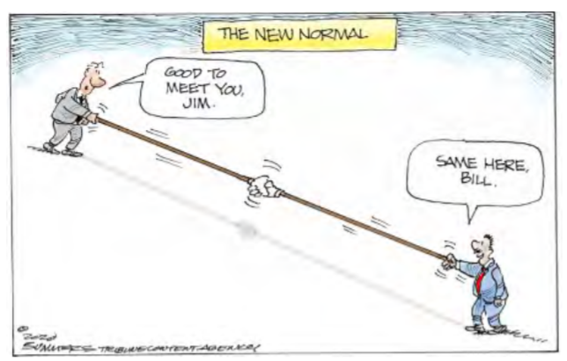
Just think about it. The internet is allowing the news media to continue providing the news to the public, entertainers continue to entertain the public, and it is allowing world leaders to continue leading the world, all while allowing everyone to observe social distancing.

And lastly, consider telemedicine. Telemedicine and virtual doctor appointments are becoming available because of, yes, you guessed it, the internet. I haven’t tried it yet but I guess you connect from your device to the doctor’s office device via - again, you guessed it, the internet. And you can have a video chat where you describe your symptoms and possibly give the doctor some of your vitals like blood pressure and heart rate if you have a reliable blood pressure machine. The doctor can see you and assess your demeanor and possibly other things from the answers you give to some particular questions; he can then decide on a diagnosis. And if all that is successful, the doctor’s office can send a prescription to your pharmacist, all the time allowing everyone to maintain their own social distance. How great is that? I just can’t wait for 5G.

